Līdzfinansē Eiropas Savienības
Erasmus+ programma
FOR THE BETTER FUTURE FOR THE STUDENTS OF THE NEXT GENERATION (01/09/2016 – 30/09/2018)
PROJECT ACRONYM – FBFSNG
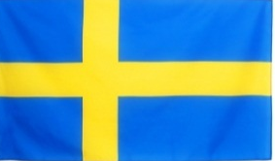
COORDINATOR: KLIPPAN GYMNASIESKOLAR/TEGELBRUKSSKOLAR (Public, Vocational training – secondary level, 276 students, aged 16-19)
KLIPPAN, SKANE, SWEDEN
PARTICIPANTS:
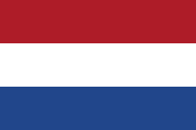
- ORANJE NASSAU COLLEGE (Public, General education – secondary level, 1250 students, aged 12-18) ZOETERMEER, ZUID-HOLLAND, NETHERLANDS

- MADONA STATE GYMNASIA (Public, General education, 253 students, aged 14 – 19)
MADONA, VIDZEME, LATVIA

- COLLEGIO ROTONDI (Private, General education, 450 students, aged 7-19; school is over 400 years old)
GORLA MINORE, LOMBARDIA, ITALY
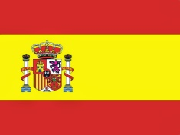
- IES CAMPANILLAS (Public, General/vocational, 600 students)
MALAGA, ANDALUSIA, SPAIN

- ZESPOL SZKOL TECHINCZNYCH I PLACOWEK im.ST.STASZICA W NOWYM TARGU (Public, Vocational training – secondary level, 1600 students)
NOWY TARG, MALOPOLSKIE, POLAND

