Newsletter 3
Youth without borders
Comenius project 2013-2015
Happy New Year!
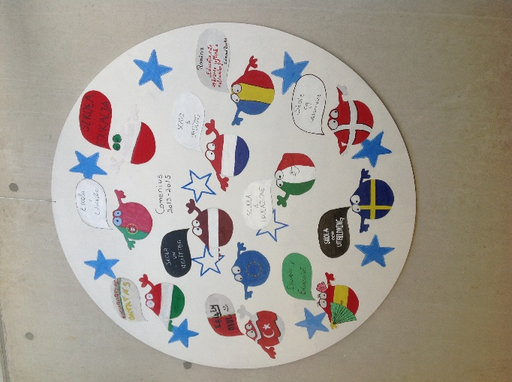
Welcome everyone to the third newsletter. Now all the 11 countries have met 3 times and we have gained a good feeling of solidarity. We have found out that we have so much in common and at the same time we have learnt about the differences of the countries which has been very interesting. I guess everybody is looking very much forward to meet again:
And we are meeting in:
Latvia: 3rd March – 7th March Hungary, Sweden, Italy and Latvia
Holland: 2nd March – 7th March Portugal, Turkey, Denmark and Holland
Poland: 10th March – 14th March Spain, Rumania and Poland
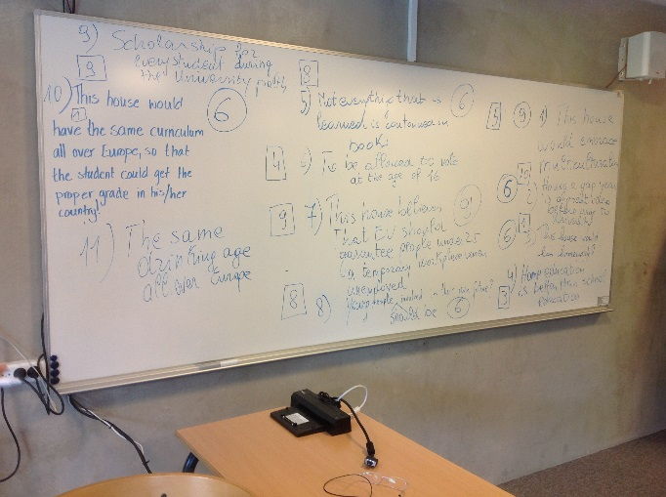
And then the very last meeting :
Italy: 15th April – 19th April
We have received the “Debating Rules” for the meeting

After Sweden came Denmark
As written in the last newsletter we had an unforgettable trip to Sweden and it was hard to be the next hosting country.
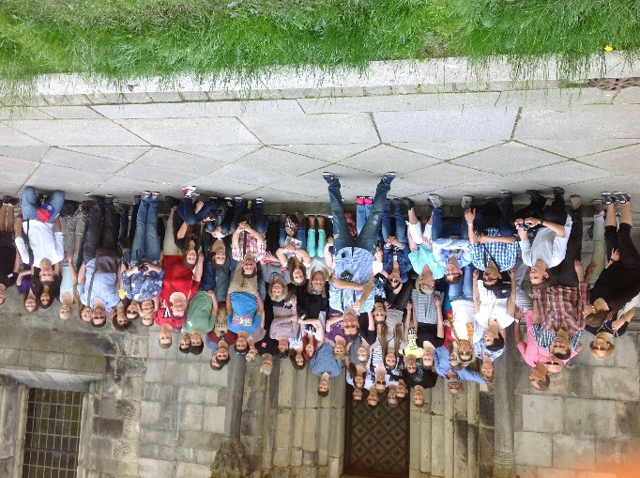
We did it and it has been so nice to be your host for the 5 days in October and you were brilliant visitors, teachers and students. You took part in the activities – worked, experienced or just were together.

The students made well prepared and excellent presentations:
Italy: Housing for international students who want to study abroad.
Latvia: Local art: Theater, art, opera, cinema and music
Poland: A survey: Last grades students´ choices
Romania: The complete presentation of the educational system
Sweden: Social media
Turkey: The complete presentation of health care
Spaini: National scholarship
Hungary: National traditions
Holland/ Portugal: Youth unemployment
Well speaking young Europeans told about the different subjects in a lively and informative way.
Well done!

What some students wrote about their stay in Denmark:
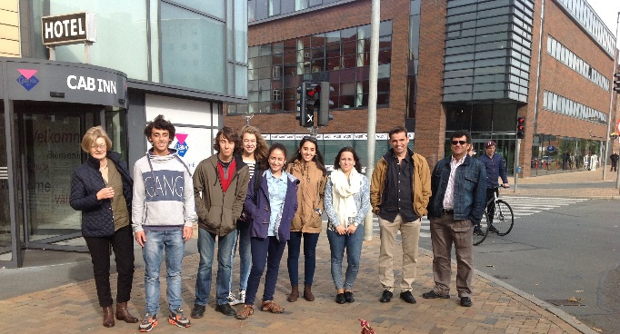

From Portugal:
On 3rd October 2014, six students from José Sanches e S.Vicente da Beira school aggregation set on trip to Denmark, participating in the Comenius project. At around 19:20 we got in the train to Lisbon.
In our first night we slept in a school’s gym. Next morning we went on a plane destined to Copenhagen. The adventure had begun. Once in Copenhagen, we visited the city and its touristic area. By the end of the afternoon we got on the train to Odense, where we would spend the night. On Sunday, we had the chance to get to know this city too, and we visited the beautiful gardens of Hans Chrisitan Andersen; we also saw some typical churches and other monuments. The delegations from Poland and Romenia arrived that afternoon and we took them to see the city and later, after we all had dinner, we spent some time together at the Hotel’s living room.
On Monday, the rest of the delegations arrived and in the afternoon, the host families came to take the students to their homes. The next day, everyone met at the school, starting a day full of activities: first we saw a welcoming presentation made by the Danish students, then we visited the school ( it was very modern and technologically up to date, by the way), and after that we took a break for lunch.
In the afternoon, we attended several lectures on the workings of the Danish educational system, and the presentations of the work that had been developed for each country were made after each of the students went to their house. Wednesday was the day to visit a beautiful castle, the Egeskov castle, ending the day with dinner at the bowling alley where we played and we had a nice interaction between all the countries.
Thursday morning we participate in an art activity in which country had to create your flag and then combine them into one big screen. That same day, we also visit the town of Odense again, but this time with tour guides. At the end of the visit we had another moment to live among us and still buy some souvenirs. The next day at around 18: 00h we were already on Portuguese soil, ending what has been a very rewarding experience because we've been in contact with another reality.
That said, I can only advise everyone to sign up for projects like this!
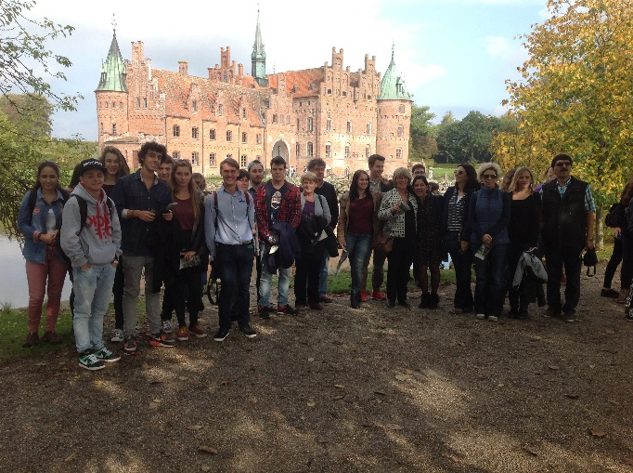

From Latvia:
The trip to Denmark was a great opportunity to find out more about the Danish culture, language and traditions. During this trip we visited historical places, where we learned the most important things about Danish history. All the week, we tried different kinds of Danish traditional food, which was really tasty.
The main goal for this trip was to find out more about countries which are involved in this project. Most of the time, we worked at school, which was a little different from schools in Latvia. In these five days, I got many new friends. They told me interesting things about they countries. My host family was lovely and kind. They made me feel like home. I hope I will meet them again. I found out that for Latvians it’s really difficult to speak Danish and for Danish people it’s difficult to speak Latvian, because our languages are completely different.
I think Denmark is a beautiful country and if you have been in this country, you will return there again.
And more from Latvia:
I really enjoyed my time in Denmark. Especially, I liked the people because they were so polite and kind everywhere: at school and in the family. We learned a lot about the Danish culture and school system and it was interesting because it’s different from Latvian. I learned a lot from my host family, and they were really nice and helpful, that’s why I got this great impression about people in Denmark. Another great benefit of this trip was the opportunity to improve my English language skills, which I think is very important. It was a great experience to meet students from 11 countries and to see that we all are so different but at the same time we have so much in common.
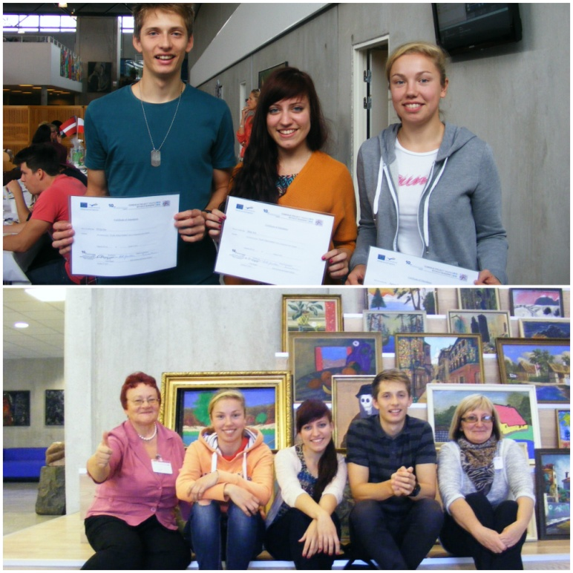

From Holland
Denmark 2014
Lourdes Melese

My experience in the Danish household was really positive. I thought the family I stayed at was really welcoming and loving. We had such good and fun conversations at the dining table every night. The food was really good and I felt so welcome and accepted into the family for those three days.
The school was really different compared to what I’ve seen in Portugal, as well as my own school. It was really modern, open-spaced and it felt free in a way. We got a tour around both of the departments of the school and we learned a lot about the Danish school system.
I got along really well with the other students and teachers from other countries. It is fun to see how much you can achieve just by speaking English as our main language that week. Everyone seemed really nice and interested in the different culture but also the things we had in common.
Overall I really enjoyed my stay in Denmark and I’m grateful I had the chance to participate again. I torridly enjoyed every single moment of my experiences in both countries. I had a blast.
Annick van der Sleen:
This year I joined the project Youth Without Borders. We went with four students from Oranje Nassau College to Denmark. In Denmark we worked with students from 10 different European countries on this project. We gave presentations and went on trips. I really liked joining this project and I`ve learned a lot from it. This project was good for my English, because that was the language everybody had to speak. We slept in Danish host family which was very exciting because you don^t know those people. My host family was very nice! I`ve learned a lot from all the experiences and I met a lot of new and friendly people. I`ve had a great time in Denmark.
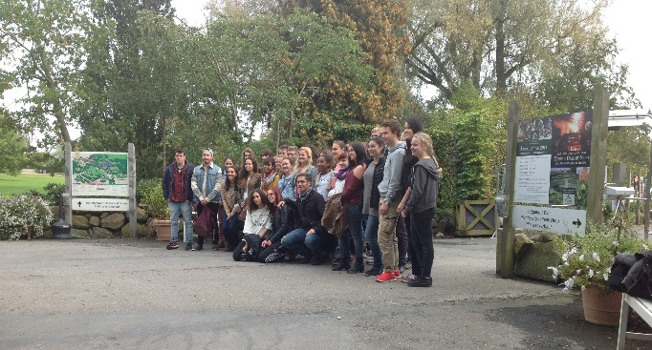

From Poland:
I really enjoyed this trip because everything was awesome there. I met new people, saw Danish cities, improved my English and had a very good time. The school was new and modern, there were couches and computers on the corridor. Everybody was nice for me and tried to help me when I had a problem. I visited Copenhagen and Odense city which are very beautiful. There are a lot of scheduled buildings, parks and old churches. I like Danish culture and history. I would like to visit Denmark again.
I was waiting a long time for the Comenius Project. I was very excited for the day of travel, and I was very happy to meet people from other countries! When we landed in Denmark I was wondering how my „new family” would look like…
These days were the best days in my whole life. In Denmark we visited a lot of beautiful monuments and beautiful cities. I saw different cultures, traditions and languages, but the best was meeting with people from other countries. I met fantastic friends! I will never forget them! I think that all students in this Comenius Project are the same – we have the same problems, the same hobbies, and we smile in the same language :) That’s why we made friends with one another so easily! I hope we will meet again in the future!
I really miss them. I also miss Denmark! New friendships, new experiences, and amazing memories. I think that all students should participate in the Comenius Project, because „young are without borders”!
My name is Jagoda and I took part in the Comenius project YWB. When I found out that I was going to Denmark, I was very happy and I couldn’t wait for the date of departure.
When we landed, I was very stressed, but also excited to meet new people and visit new places.
“My Danish family” was great! I spent a great time with them. The new school was very modern and different from that in Poland.
All the people were great. I made friends, and it continues even after returning from that meeting. I hope that I meet them in the future. I think I will never forget this experience.
I have realized that even we come from different countries and cultures, we have the same problems and interests.
I miss Denmark. After that trip I want to explore other interesting places and learn new things.
I believe that every student should take part in this project, because it develops our personality.

From Turkey
Aysenur Inceoglu:
I think your school architecture is amazing. The backyard, dining hall and classes made me want to take education in your school. The opportunities that your school give are excellent. But I saw one thing that made me sad, because most of your students don’t care about school, lessons and teachers. They are playing their iphones, ipads and laptops during the lesson. If I had a school like yours, I would wake up every Monday happy.
Living in a host family was the most exciting thing I`ve ever done in my life. They were unexpectedly kind and tolerant. You know, I am from Turkey so I am Muslim. Pork is forbidden in my religion. They were so understanding about this situation. Josefine`s mother was so conneted with me, this part was best for me. She asked questions about my country, my daily life, our education system etc. And then she answered my questions kindly and she was so patient to me. And Josefine, I guess she was the coolest girl in Denmark. She took me for a walk around Assens, she showed me the place that she living, she explained to me, that was cool! So you know, I am sure that I was the luckiest one in the Comenius project.

From Hungary:
Bence Borsos
A month ago I had the golden opportunity to travel to Denmark. I took part in an international project called Comenius, Youth without Borders. My hosts were really kind to me all the time and I had a fantastic week in Denmark in Glamsbjerg. I will never forget this fantastic experience. I lived with a beautiful family, they were so nice to me and we became friends with my host, Mikkel. I liked to see their way of living, and taste their food which I liked so much.
During the day we were at their school, so I was able to see their teaching methods; I liked it so much because their education system is totally different, it was interesting to see how they educate their children.
One day we went on a little trip to visit a castle called Egeskov Slot, it was huge and impressing. There was a vintage car exhibition which had a big influence on me, because I really like these types of cars from old days.

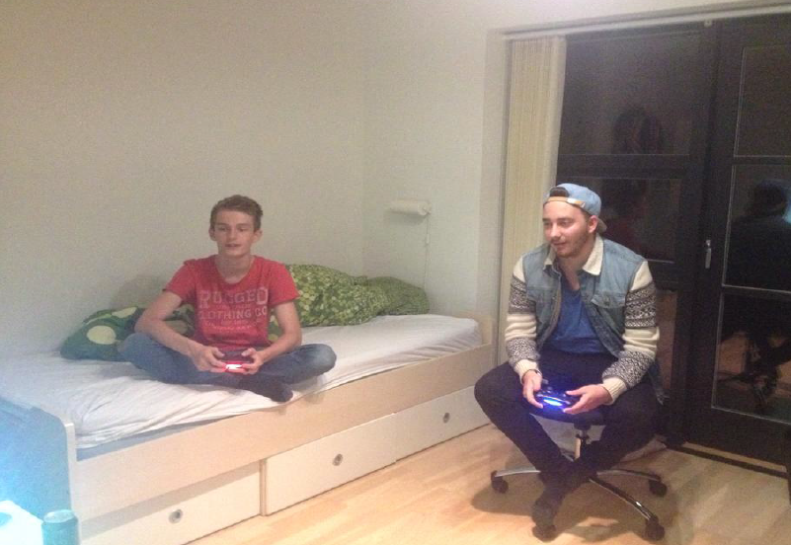

Once all of the students and their hosts went to a bowling pub for dinner and for some fun. Maybe that was the best night, it was truly entertaining and we could get to know each other better during the night. All in all it was a fantastic experience for me and it was a pleasure to be their guest for a week.
Regards, from Hungary.
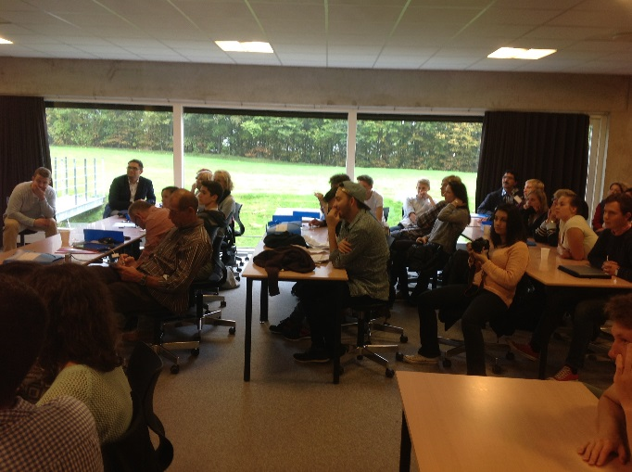

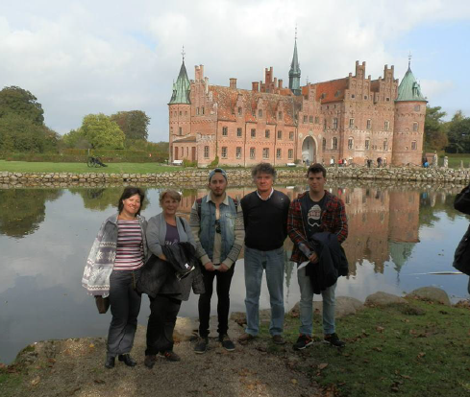

From Italy:
Before I came to Denmark, I was a bit scared because I am shy, it was the first time I travelled with only one of my classmates and I thought that I wouldn’t have spoken with no one. But when I was there I changed my mind and it was a beautiful experience! I stayed in a nice family that looks after me as I was one of their relatives; I learn things about the Danes culture, a bit different from the Italian one; I meet some new friends and I had the possibility to improve English (of course!) and Spanish too.
One of the best things I realized thanks to this experience, it is that, although we came from different countries, we can have the same tastes about music, films, books, sports… and we can play together also with only some planes made with papers
I think that the most beautiful place we visited is the Egeskov castle and the park round it; it was a sunny day, although in Denmark usually it is not so hot in that period, and during that afternoon we took lots of pictures, we walked on a path through the trees, we got lost in a labyrinth… we had lots of fun!! But if we talk about cultural visits, the most interesting one was the afternoon in Odense, city where Hans Christian Andersen was born, because we knew something about his life, his books and we also visited his house, that now it’s a part of a museum.
Giulia Dal Zotto, Italy
From Spain:

First of all I want to thank my host family because they were very nice and everyone else who made this project possible like our teachers
The experience in Denmark was incredible. The everyday life was really different to the life in Spain. I was very lucky because I could know new culture. At the beginning when I hadn`t met anybody yet, I felt strange, but then I realized that it didn`t matter since everybody was friendly. My host house was really large, I was surprised since I had to walk barefoot. In Spain I love walking barefoot but my mother always scolds me. Other different thing for me was that there weren`t many houses around my house, so that, the landscape was a beautiful. My host friend was very funny ans she taught me some Danish words and play card games.
The food was really good, I loved it. I could taste typical and varied dishes from Denmark.
We visited Egeskov Castle and Hans Christian Andersen`s house. We did a lot of kinds of activities, it was very funny. We met people from other countries. This was great sinceyou can appreciate other tyoes of mentality, religion, language. I really felt at home.

