Comenius project
Youth Without Borders
Coordinator: Collegio Rotandi, Gorla Minora, Lombardia, Italy
Participants:
- Klassecenter Assens, Glamsbjerg, Denmark
- Madona State Gymnasia, Madona, Latvia
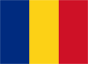
- Gimnazjum nr.3 pro Jozefa Sarny, Tamobrzeg, Poland
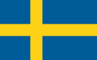
- Liceum Teologic Romano-Katolic „Sfantul Francisc de Assisi”, Roman, Romania
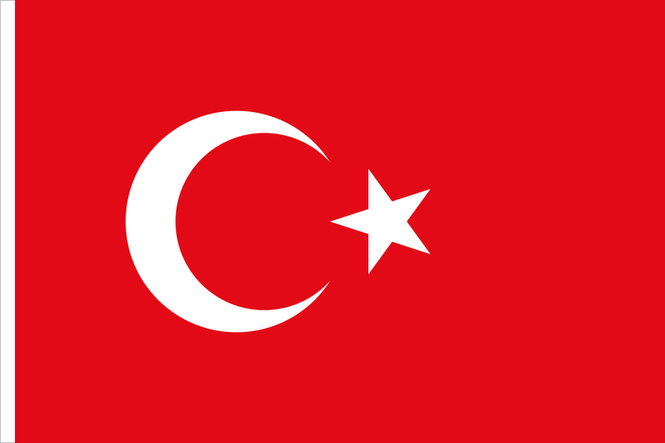
- Design and Construction College, Helsingborg, Sweden
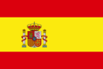
- Nazilli Fen Lisesi, Nazilli/ Aydin, Turkey
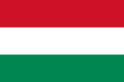
- IES campanillas, Malaga, Spain
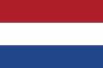
- Szinyei Merse Pal Gimnazium, Budapest, Hungary
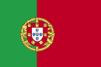
- Oranje Nassau College Parkdreef, Zoetermeer, Netherlands
- Argupamento de Escolas Josē Sanches e Sāo Vicente da Beira, Alcains, Portugal

